

**CIS 11042 – Practical for Essential of ICT and PC Applications**

Information and communication Technology

Faculty of Technology

South Eastern University of Sri Lanka

Registration Number: SEU/IS/22/ICT/075

Academic year: 22/23

Date: 21.03.2023

**Exercise 01**

1. Selecting the insert tab in ribbon tab

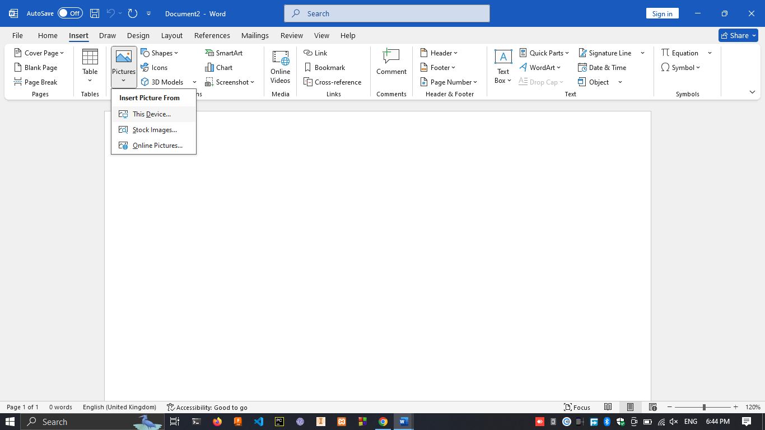

1. under the picture format select on crop and select any shape to crop. ( I’m selecting oval shape)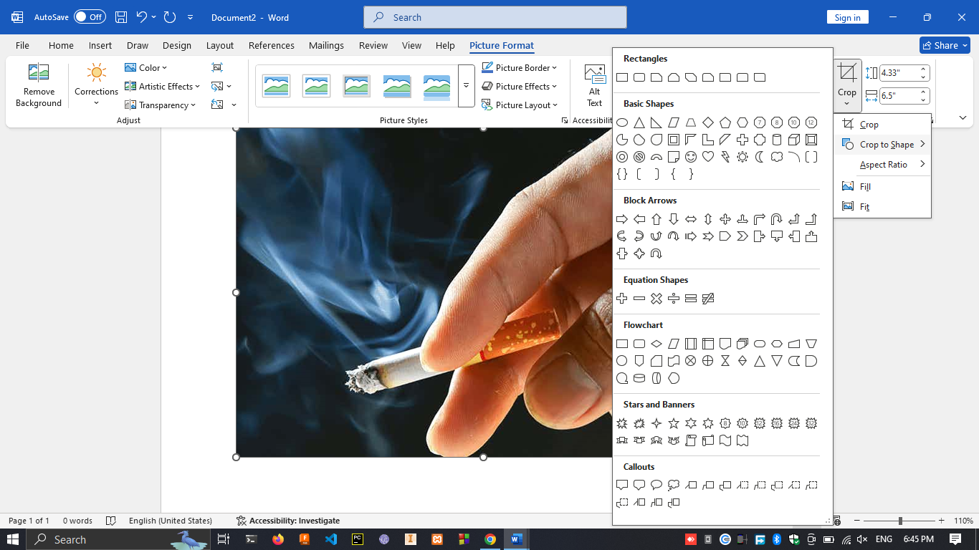
2. Under picture border selecting red as border and changing border weight.

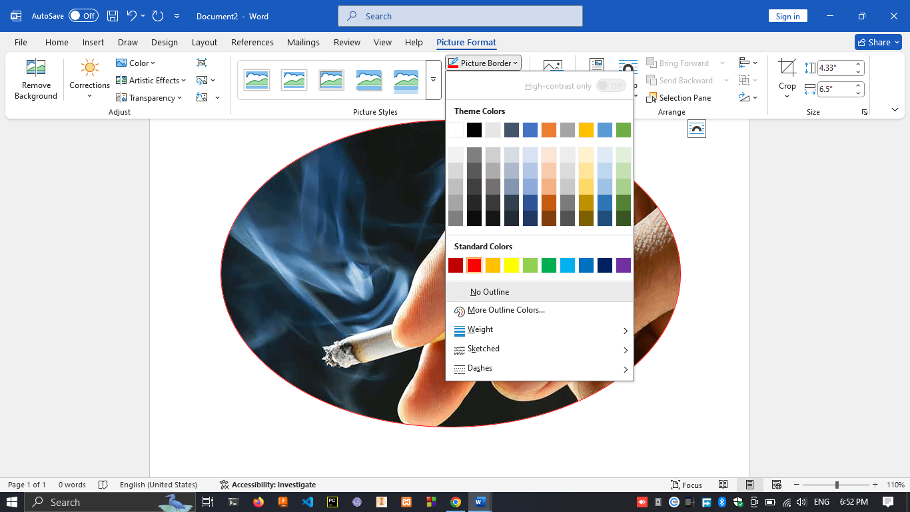

1. Under picture format select effects under artistic effects.

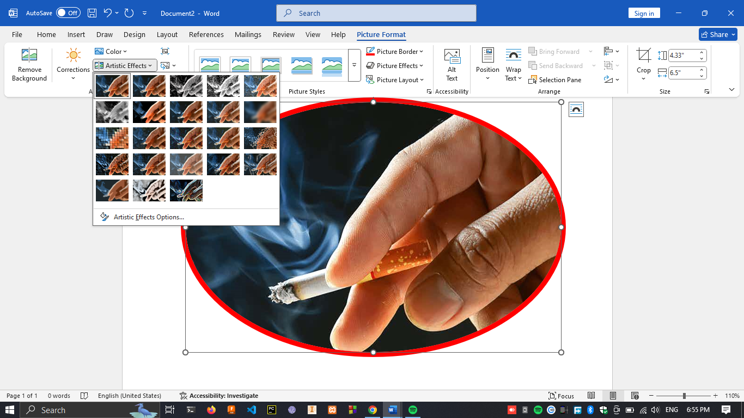

1. Select Corrections under picture format

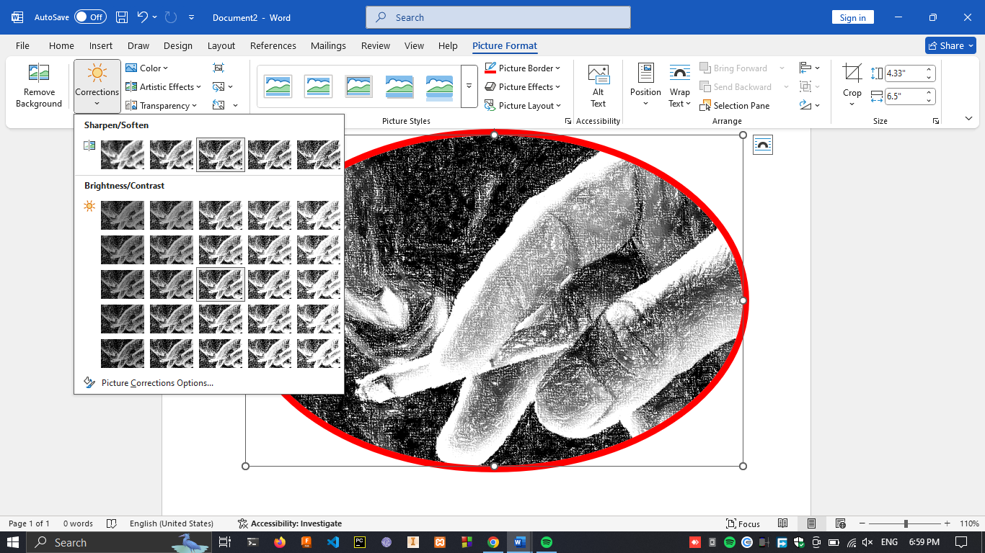

**Exercise 02**

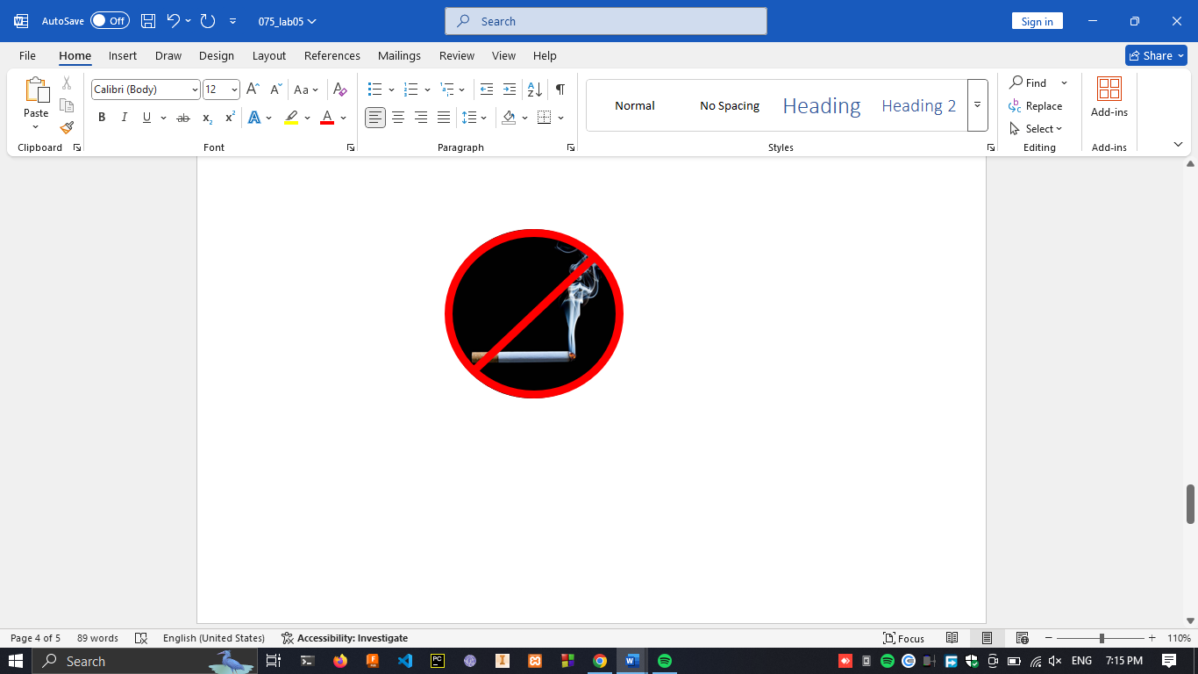

**Exercise 03**

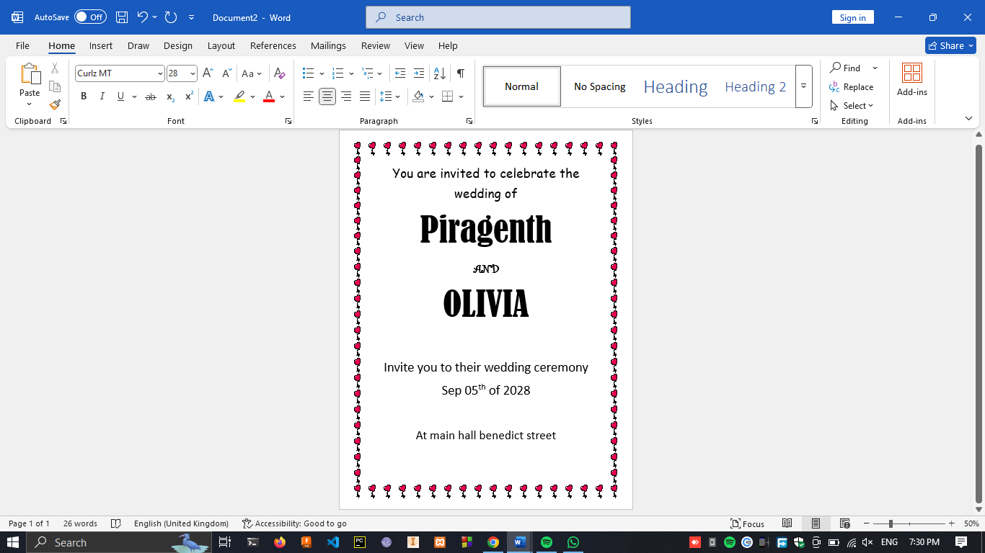

**Exercise 05**

